Clausentum Fen Conservation Management Plan 2017-2022
CHAIRMAN’S SUMMARY
Marcus Swalwell
20 March 2017
Clausentum Fen is an approximately 1.9 hectares (4.5 acres) SINC adjacent to the River Itchen SSSI. Grid SU4728SE. It is on a 999yr lease by HCC from PGC Construction Ltd.
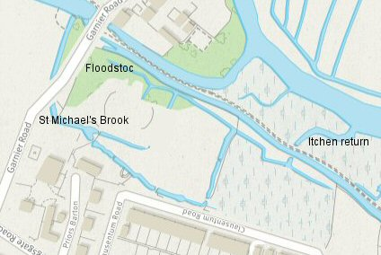
Water has been the most influential factor in the development of the site over the centuries as town drainage, water meadow and mill workings have changed nature’s original scheme. Now two legacy streams (St Michael’s Brook on the west and Floodstoc River on the east) convey high quality chalk stream water into the upper site. These streams converge halfway down the site and then flow out under Lockburn Stream and Keat’s path into the River Itchen.
Water is the “life-blood” of Clausentum Fen. The shallow, fast flowing streams are a nursery for important species that repopulate the Itchen. The greatest threat to the fen is the restriction of St Michael’s Brook flow by sluices in the Mill leat above Garnier Road.
Diverse water life also requires a balance of good light for basic vegetation and protective cover for the vulnerable predated species. Our plan addresses the management of reliable water flows, sunlight and protective cover. The site can be usefully described in four roughly equal zones:
Zone 1 beside Garnier Road is heavily wooded from its time as Priors Barton’s ornamental garden. Some TPO approved tree management is needed to improve light for the stream and ground flora and the path between Garnier and Clausentum Roads. Bird and bat boxes will be deployed here.
Zone 2 picks up St Michael’s Brook after it has passed through the Priors Barton gardens and the turns across the middle of the site. There is a popular children’s play area around the large, climbable beech tree and the rest of the zone is either more open woodland or protective dogwood scrub along the Floodstoc stream. Water flow and sunlight in the streams are the key issues again.
Zone 3 is thickly litter-matted from years of sedge overgrowth. Ideally, we would like to restore diverse wetland flora by extending the draining of St Michael’s Brook across its southern bank. The rapidly expanding bamboo patch has been cut down and we have yet to determine the best practical management approach (grazing v mowing and removing grasses) for this area.
Zone 4 lies across a high dividing bund and falls to the lowest level of anywhere on the site. We aim to encourage amphibia, newts, water based insects, dragonflies and small mammals with a standing water pond in the centre of this zone.
Our overall goal is to establish Clausentum Fen as a Local Nature Reserve supported by HCC. We aim to do this by managing the site to optimise its biodiversity potential balanced with restoring its natural beauty and maintaining its delightful children’s play area and shortcut walk.
www.clausentumfen.co.uk is our information hub to inform, share, educate and coordinate the 50-strong membership of the Clausentum Fen Conservation Group. Much of our management can be achieved with volunteers but accurate monitoring, fencing, tree work, bamboo root excavation and waterways require external cooperation and funding.

